Thema
Datum | 09.01.2018
Verfasser(in) | Felix Werder, LIOI
Telefon | 044 292 72 14

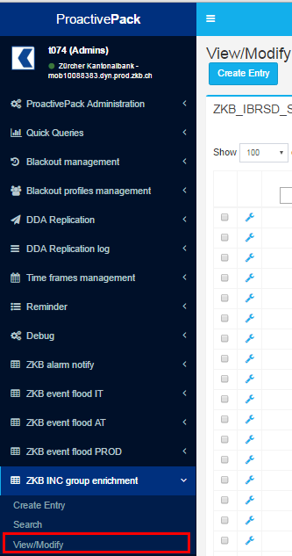 | Select View/Modify
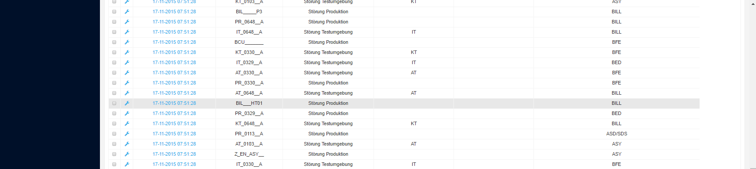 | Scrolling down the findings.  The darkblue windows disappears above.
We request that the menu items doesn’t move above while scrolling the findings.

